Height adjustable packing table with Corian worktop

Description: Ergonomic considerations play an ever increasing
role in the working environment. Not only work satisfaction can be increased but also the risk of health complaints can be drastically diminished.
A very important consideration in ensuring a good work posture is the height of the worktable top. In certain
circumstances an alteration of the table height will not
automatically lead to a lasting solution to a problem.
For example, whenever a lot of different people of various heights and postures are required to use the same worktable or when certain tasks are alternately performed in a standing and then a sitting position.

As a solution to this problem, Famos has designed electrically height adjustable worktables that are operated by means of two push buttons to adjust the table to a height from 770mm to 1200mm.

The table is also equipped with four memory buttons in which a certain height can be programmed.

The height adjustable table above is equipped with a Corian worktop, Stainless steel stand 25x25x1,5mm with a fluorescent lightning of 2x36 Watt, a stainless steel shelf/cover plate, a stainless steel drawer cabinet with 3 drawers push to open. .

The picture is illustrative

The table is completely made of AISI 304 stainless steel with exception of the worktop which is made of Corian and the columns which are made of aluminium.

The height adjustable columns operate on 220V-50Hz and have a capacity of 550kg.

The table 00.000.011 is equipped with the following:
- Corian worktop in colour Vanilla
- Upright partition made of stainless steel 25x25x1,5mm columns which is equipped with a stainless steel shelf/cover plate 1800x300mm. WxD
- Fluorescent lighting of 2x36 Watt is mounted underneath the stainless steel cover plate.
- The lighting can be dimmed. An ON/OFF switch included.

In addition the table can be equipped with the following:
- Colom stand for integrated power, data and air supply.
- Stainless steel drawer cabinet, equipped with 2, 3,or for drawers. All drawer cabinets have a smooth finish without handles for better hygiene and can be opened with a “push to open” system.
- Open Stainless steel frame for basket, shelves or trays, equipped with 5 pair of U-profiles
- Magnifying lamp
- TFT screen holder
- PC Cabinet for construction under worktop
- Keyboard holder for construction under cabinet
- Cable management under the worktop
- A Corian worktop thickened to 30mm
- Triple power supply integrated in colom stand
- Double data supply integrated in colom stand
- Pressurized air supply integrated in colom stand
- Pressurized air pistol with hose 1,5mtr

Product: Height adjustable packing table with Corian worktop, upright partition out of stainless steel 25x25x1,5mm, with cover plate, and fluorescent lighting
Article number: 00.000.011
Dimensions: 1800x750x770-1200mm LxWxH

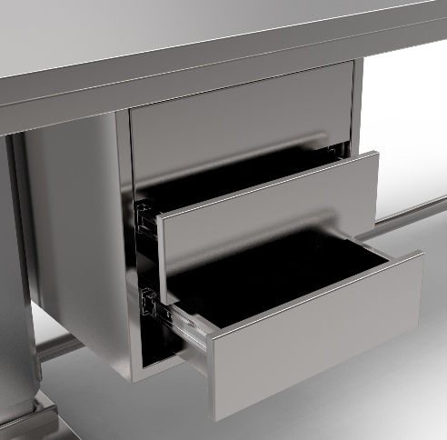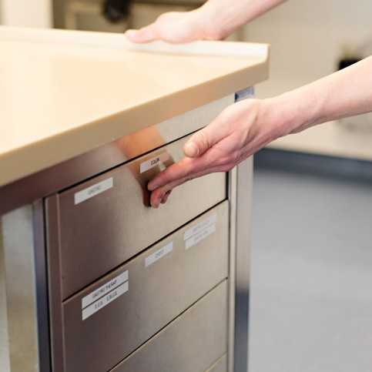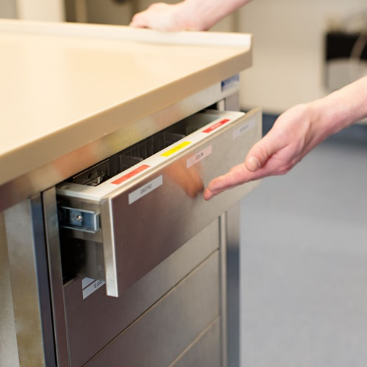
Stainless Steel drawer cabinet with push to open function
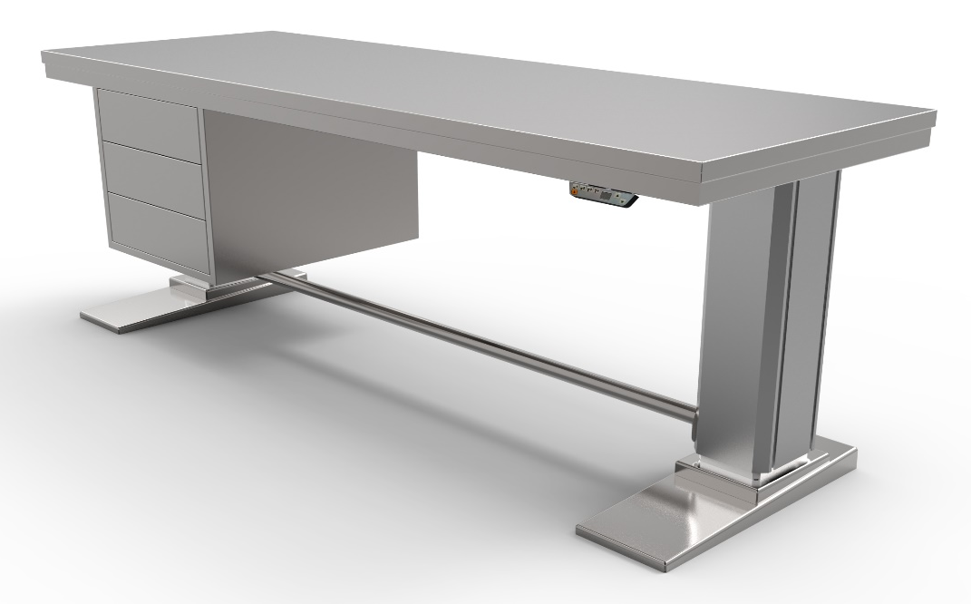
Height adjustable table without stand

Regular stand 25x25x1,5 with Stainless steel top shelf/Cover plate an fluorescent light

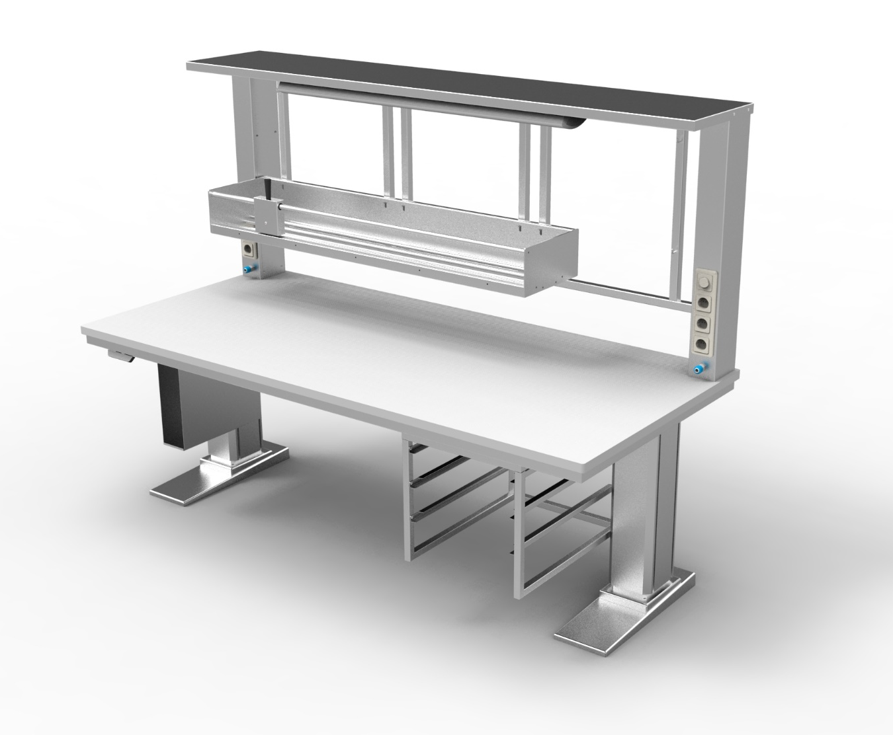
Height adjustable table with Corian cover, Colom stand with triple power supply and prisurized air supply integrated. Equiped with stainless steel shelf, Fluoriscent light, stainless steel open cabinet with 4 pair of u-profiles for ISO baskets (600x400mm). A PC holder under the worktop and a TS 1500 cutting device attached at the colom stand.

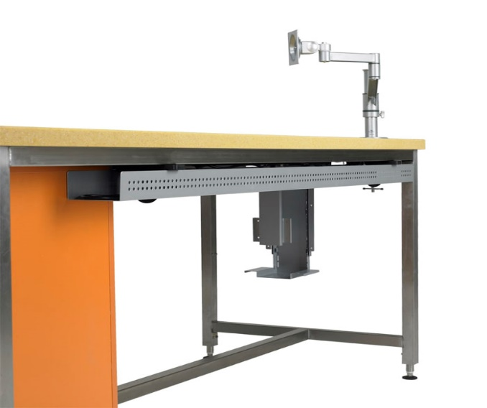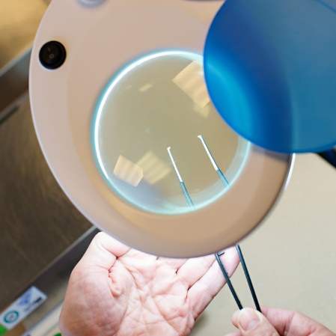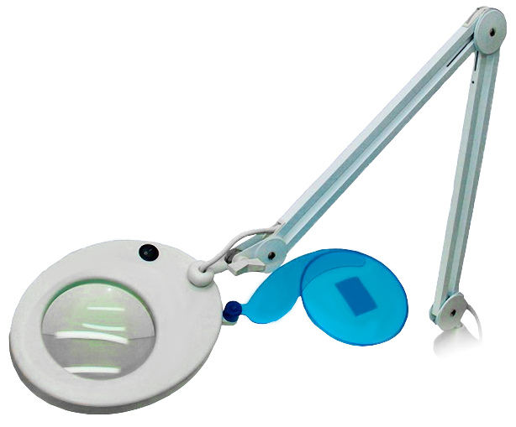
Cable management under worktop Magnifying lamp with table clamp and flexible arm

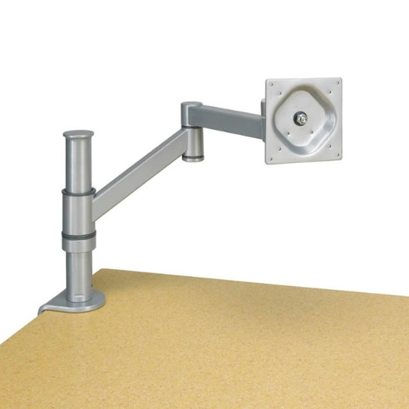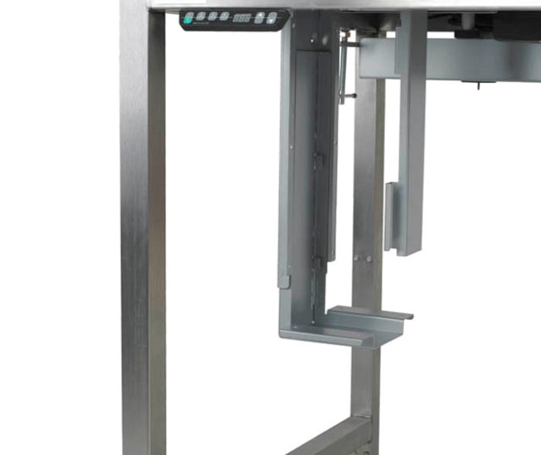

Flexible TFT arm with table clamp PC holder construction under worktop

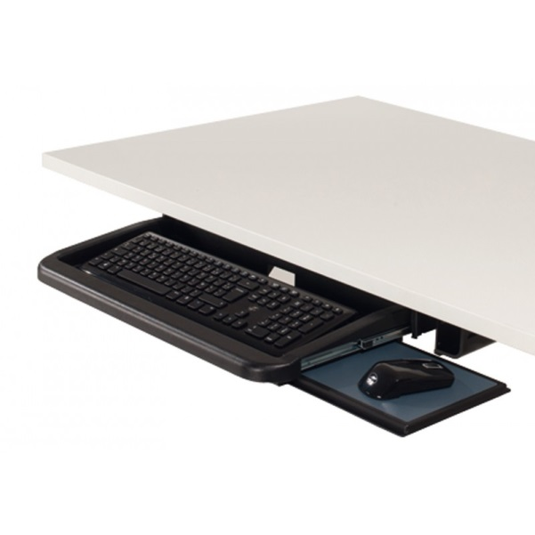

Keyboard holder construction under table Corian in the colour “Vanilla”

Specs. Magnifying lamp with 22 W neon ring - table lamp with adjustable arm and clamp
material: metal and plastic
lens diameter: 120 mm real glass lens
dioptres: 5
zoom: 2.25 x zoom
performance / fluorescent: 22 W neon ring (1 x included)
operating voltage: 230 V
attachment: table clip with screw fitting
clamping area: 6 cm
colour: white
quantity per pack: 1 piece
- table lamp with adjustable arm (120 cm)
- on/off switch on lamp
- hinged cover to protect the lens
- easy to clean
- internal springs
- light colour: cold white

